SAN BOIS CASA, INC.
KiBois Building 204 Wall Street
P. O. Box 1392
Poteau, OK 74953
918-647-3267

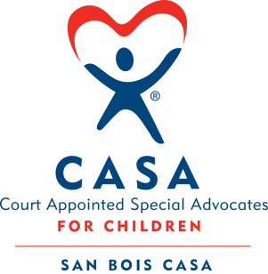

AGENDA

KiBois Community Action Center
March 8, 2018
4:00 p.m.

- Invocation

- Call to Order

- Roll Call (Compliance with Open Meeting Act)

- Welcome and Introduction of Guests

- Discussion and Possible Action on January 11, 2018 Minutes

- Discussion and Possible Action on Financial Report for January 2018

- Discussion and Possible Action on Financial Report for February 2018

- Discussion and Possible Action on Worker’s Compensation Premium

- Discussion and Possible Action on Contract Labor – Ruth McCage

- Discussion on Form 990-EZ for 2016

- Executive Director’s Report – VOCA Grant, Fat Tuesday Fundraiser

- Advocate Supervisor’s Report – Program Growth

XIII. Business not known within 24 hours of this meeting

XIV. Adjournment

Next scheduled meeting
May 10, 2018

