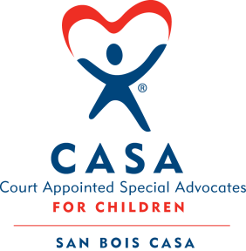
SAN BOIS CASA, INC.
KiBois Building 204 Wall St.
P. O. Box 1392
Poteau, OK 74953
918-647-3267

AGENDA

KiBois Community Action Center
June 8, 2017 – 4:00 p.m.

- Invocation

- Call to Order

- Roll Call (Compliance with Open Meeting Act)

- Welcome and Introductions of Guests

- Discussion and Possible Action on May 11, 2017 Minutes

- Discussion and Possible Action on Financial Report for May 2017

- Discussion and Possible Action on Revised Organizational Chart

- Discussion and Possible Action on Credit Card Policy

- Election of Officers for New Year and Committee Assignments

- Director’s Report – Credit Card Purchases, Donations, Directors & Officers Insurance

- Advocate Supervisor’s Report – Spring 2017 Victims Services Roundtable, Volunteer Training

XII. Business not known within 24 hours of this meeting

XIII. Adjournment

Next Meeting
July 13, 2017 – 4:00 p.m.

