SAN BOIS CASA, INC.
KiBois Building 204 Wall Street
P. O. Box 1392
Poteau, OK 74953
918-647-3267

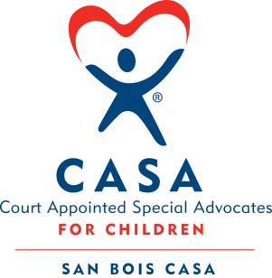

AGENDA

KiBois Community Action Center
February 17, 2022
4:00 p.m.

- Invocation

- Call to Order

- Roll Call (Compliance with Open Meeting Act)

- Welcome and Introduction of Guests

- Discussion and Possible Action on December 16, 2021 Minutes

- Discussion and Possible Action on Financial Report for November & December 2021 and January 2022

- Discussion and Possible Action to Expand into Atoka County

- Discussion and Possible Action on Updating Signatures on Bank Card

- Executive Director’s Report – Credit Card (Nov. & Dec), Audit

- Auctioneering School Fundraiser – Justin Kennedy

X. Business not known within 24 hours of this meeting

XI. Adjournment

Next scheduled meeting
March 24, 2022

