SAN BOIS CASA, INC.
KiBois Building 204 Wall Street
P. O. Box 1392
Poteau, OK 74953
918-647-3267

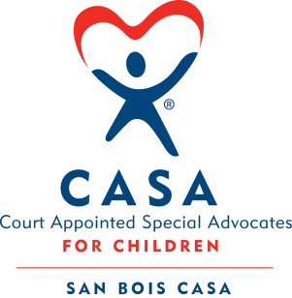

AGENDA

KiBois Community Action Center
January 11, 2018
4:00 p.m.

- Invocation

- Call to Order

- Roll Call (Compliance with Open Meeting Act)

- Welcome and Introduction of Guests

- Discussion and Possible Action on December 14, 2017 Minutes

- Discussion and Possible Action on Financial Report for December 2017

- Discussion and Possible Action on Additions to Volunteer Policies and Procedures

- Discussion and Possible Action on 2017 Audit

- Discussion and Possible Action on Repayment of Employee Advances

- Discussion and Possible Action on New Board Member – Chad Yandell

- Executive Director’s Report – Fat Tuesday Fundraiser

- Advocate Coordinator’s Report – In-Service and Pre-Service Trainings 2018

IX. Business not known within 24 hours of this meeting

X. Adjournment

Next scheduled meeting
March 9, 2018

