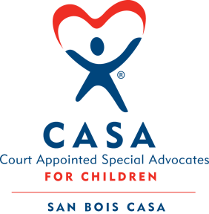
SAN BOIS CASA, INC.
KiBois Building 204 Wall St.
P. O. Box 1392
Poteau, OK 74953
918-647-3267

AGENDA

KiBois Community Action Center
June 17, 2021 – 4:00 p.m.

- Invocation

- Call to Order

- Roll Call (Compliance with Open Meeting Act)

- Welcome and Introductions of Guests

- Discussion and Possible Action on March 25, 2021 Minutes

- Discussion and Possible Action on Financial Reports for January, February, March, April, and May 2021

- Discussion and Possible Action on Goals & Objectives for 2021-2022

- Fundraising Reports – Chad Yandell and Justin Kennedy

- Director’s Report – Credit Card Purchases (April), 2021-2022 Budget Projections

X. Business not known within 24 hours of this meeting

XI. Adjournment

Next Meeting
September 16, 2021 – 4:00 p.m.

