SAN BOIS CASA, INC.
KiBois Building 204 Wall Street
P. O. Box 1392
Poteau, OK 74953
918-647-3267

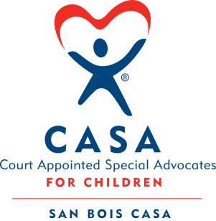

AGENDA

KiBois Community Action Center
January 10, 2019
4:00 p.m.

- Invocation

- Call to Order

- Roll Call (Compliance with Open Meeting Act)

- Welcome and Introduction of Guests

- Discussion and Possible Action on December 20, 2018 Minutes

- Discussion and Possible Action on Financial Report for December 2018

- Discussion and Possible Action on 2018 Audit – Beth Peck

- Executive Director’s Report – Fundraisers, VOCA Grant

IX. Advocate Coordinator’s Report – Pre-Service and In-Service Trainings

X. Business not known within 24 hours of this meeting

XI. Adjournment

Next scheduled meeting
March 14, 2019

