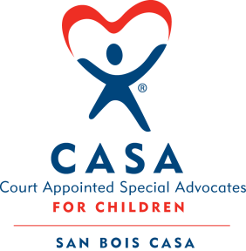
SAN BOIS CASA, INC.
KiBois Building 204 Wall St.
P. O. Box 1392
Poteau, OK 74953
918-647-3267

AGENDA

KiBois Community Action Center
May 11, 2017 – 4:00p.m.

- Invocation

- Call to Order

- Roll Call (Compliance with Open Meeting Act)

- Welcome and Introductions of Guests

- Discussion and Possible Action on March 9, 2017 Minutes

- Discussion and Possible Action on Financial Report for March 2017

- Discussion and Possible Action on Financial Report for April 2017

- Discussion and Possible Action on Resignation of Board Member Bobbie Vinson

- Executive Director’s Report – Credit Card Purchases, Child Abuse Prevention Activities

- Program Coordinator’s Report – Pittsburg County Child Abuse Prevention Conference, Volunteer Training & Updated Numbers

XI. Business not known within 24 hours of this meeting

XII. Adjournment

Next Meeting
June 8, 2017 – 4:00 p.m.

