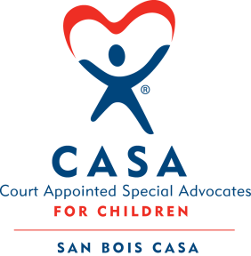
SAN BOIS CASA, INC.
KiBois Building 204 Wall St.
P. O. Box 1392
Poteau, OK 74953
918-647-3267

AGENDA

KiBois Community Action Center
June 14, 2018 – 4:00 p.m.

- Invocation

- Call to Order

- Roll Call (Compliance with Open Meeting Act)

- Welcome and Introductions of Guests

- Discussion and Possible Action on May 10, 2018 Minutes

- Discussion and Possible Action on Financial Report for May 2018

- Discussion and Possible Action on 2018-2019 Proposed Budget

- Election of Officers for New Year and Committee Assignments

- Assessment of Strategic Growth Plan Goals and Objectives

- Director’s Report – Volunteer Recognition & Training Event

- Advocate Supervisor’s Report – Pre-Service Volunteer Training

XII. Business not known within 24 hours of this meeting

XIII. Adjournment

Next Meeting
August 9, 2018 – 4:00 p.m.

