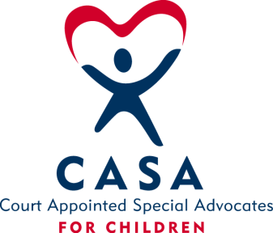
SAN BOIS CASA, INC.
KiBois Building - 204 Wall St.
P. O. Box 1392
Poteau, OK 74953
918-647-3267

AGENDA

KiBois Community Action Center
November 8, 2018

- Invocation

- Call to Order

- Roll Call (Compliance with Open Meeting Act)

- Welcome and Introductions of Guests

- Discussion and Possible Action on September 13, 2018 Minutes

- Discussion and Possible Action on Financial Report for September 2018

- Discussion and Possible Action on Financial Report for October 2018

- Discussion and Possible Action on 2018-2019 Budget Revisions

- Discussion and Possible Action on Outcome and Service Model/Organizational Values

X. Director’s Report – 2018/2019 Oklahoma CASA Grants, Fundraisers

XI. Advocate Coordinator’s Report – Court Improvement Program Training, Volunteer Trainings

XII. Business not known within 24 hours of this meeting

XIII. Adjournment

Next Meeting
December 13, 2018

