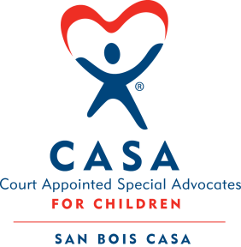
SAN BOIS CASA, INC.
KiBois Building 204 Wall St.
P. O. Box 1392
Poteau, OK 74953
918-647-3267

AGENDA

KiBois Community Action Center
September 14, 2107 – 4:00 p.m.

- Invocation

- Call to Order

- Roll Call (Compliance with Open Meeting Act)

- Welcome and Introductions of Guests

- Discussion and Possible Action on August 10, 2017 Minutes

- Discussion and Possible Action on Financial Report for August 2017

- Discussion and Possible Action on Fiscal Year-End Cash Flow Report

- Discussion and Possible Action on MOU with RSVP (Retired & Senior Volunteer Program)

- Executive Director Evaluation

- Director’s Report – Credit Card Purchases

- Advocate Coordinator’s Report – Volunteer Training

- Business not known within 24 hours of this meeting

- Adjournment

Next Meeting
November 9, 2017 – 4:00 p.m.

