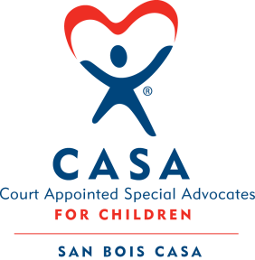
SAN BOIS CASA, INC.
KiBois Building 204 Wall St.
P. O. Box 1392
Poteau, OK 74953
918-647-3267

AGENDA

KiBois Community Action Center
September 13, 2018 – 4:00 p.m.

- Invocation

- Call to Order

- Roll Call (Compliance with Open Meeting Act)

- Welcome and Introductions of Guests

- Discussion and Possible Action on August 9, 2018 Minutes

- Discussion and Possible Action on Financial Report for August 2018

- Discussion and Possible Action on Fiscal Year-End Cash Flow Report

- Discussion and Possible Action on Online Communication and Social Media Policy

- Proposed executive session: Possible discussion and vote to enter Executive Session pursuant to 25 O.S. § 307(B)(1)1 to discuss annual evaluation of Executive Director

- Vote to Return to Open Meeting

- Director’s Report – Credit Card Purchases, Poteau Office Space

- Advocate Coordinator’s Report – Golf Tournament Fundraiser

- Haskell County Fundraiser – Debbie Williams

- Business not known within 24 hours of this meeting

- Adjournment

Next Meeting
November 8, 2018 – 4:00 p.m.

