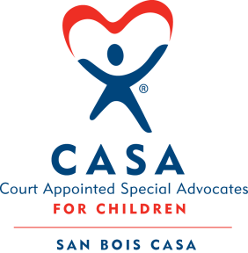
SAN BOIS CASA, INC.
KiBois Building 204 Wall St.
P. O. Box 1392
Poteau, OK 74953
918-647-3267

AGENDA

KiBois Community Action Center
September 22, 2022 – 4:00 p.m.

- Invocation

- Call to Order

- Roll Call (Compliance with Open Meeting Act)

- Welcome and Introductions of Guests – Ashlee Johnson

- Discussion and Possible Action on July 28, 2022 Minutes

- Discussion and Possible Action on Financial Reports for July & August 2022

- Discussion and Possible Action on Review of Policies Schedule

- Discussion and Possible Action on Personnel Policies & Procedures

- Discussion and Possible Action on Volunteer Policies & Procedures

- Director’s Report – Credit Card (May, June & July 2022), VOCA & OCASAA Grants, Superhero Run

XII. Business not known within 24 hours of this meeting

XIII. Adjournment

Next Meeting
December 15, 2022 – 4:00 p.m.

