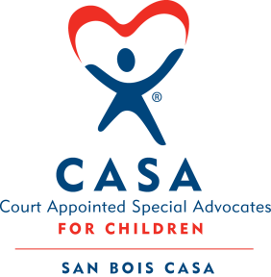
SAN BOIS CASA, INC.
KiBois Building 204 Wall St.
P. O. Box 1392
Poteau, OK 74953
918-647-3267

AGENDA

KiBois Community Action Center
May 10, 2018 – 4:00 p.m.

- Invocation

- Call to Order

- Roll Call (Compliance with Open Meeting Act)

- Welcome and Introduction of Guests

- Discussion and Possible Action on March 8, 2018 Minutes

- Discussion and Possible Action on Financial Report for March 2018

- Discussion and Possible Action on Financial Report for April 2018

- Executive Director’s Report – Credit Card Purchases

- Advocate Supervisor’s Report – New Volunteers, OKCASA State Conference

XI. Business not known within 24 hours of this meeting

XII. Adjournment

Next Meeting
June 14, 2018 – 4:00 p.m.

