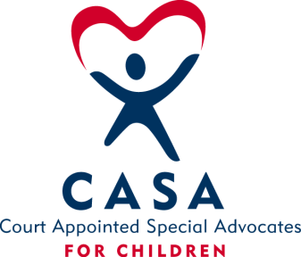
SAN BOIS CASA, INC.
KiBois Building - 204 Wall St.
P. O. Box 1392
Poteau, OK 74953
918-647-3267

AGENDA

KiBois Community Action Center
November 10, 2016

- Invocation

- Call to Order

- Roll Call (Compliance with Open Meeting Act)

- Welcome and Introductions of Guests

- Discussion and possible action on September 8, 2016 Minutes

- Discussion and possible action on Financial Report for September

- Discussion and possible action on 2016-2017 Budget Revisions

- Discussion and possible action on 2017 Board Meeting Dates

IX. Director’s Report – 2016/2017 Oklahoma CASA Grants & 2016 Golf Tournament

X. Advocate Coordinator’s Report – Pittsburg County Update & New Volunteers

XI. Business not known within 24 hours of this meeting

XII. Adjournment

Next Meeting
December 8, 2016

